Abdul-Samad Olagunju

Ms. Dalal

AP Programming

November 7, 2018

**Create a Chat Bot Design Document**

**Timeline:**

November 1, 2018- Finished Activity 1 and 2

November 4, 2018- Finished Activity 3 and 4

November 7, 2018- Created Design Document

**User Manual**

* Terminology Used:
  + API — An abbreviation for Application Programming Interface. It is a specification intended to be used as an interface by software components to communicate with each other.
  + Chatbot — A program that conducts a conversation with a human user.
  + Code refactoring — A disciplined technique for restructuring an existing body of code, altering its internal structure without changing its external behavior.
  + Magpie — Magpies are large black birds. They are thought to be among the most intelligent birds and are capable of mimicking human speech.
  + NLP — Natural Language Processing; the field that studies responding to, and processing, human language.
  + Virtual agent — Also known as an Intelligent Agent. This can be used to gather information from a customer so that appropriate action can be taken in response to a query.
* Tools and Processes Used:
  + Method- GreetingUser
    - Greet user and ask question
  + Method- Outputresponse
    - Output response of chat box
  + Method- IWantto
    - Transform statement that contains I want to and respond with question
  + Method- transformYouMe
    - Transform statement that contains you or me and respond with question
  + Method- findKeyword
    - To detect a keyword in a string
  + Method- string.indexOf
    - To retrieve the index of a certain character in a string
  + Method- string.substring
    - To take a certain portion of a string
  + Method- string.toLowerCase
    - To turn a string into all lowercase letters
  + Method- string.length
    - To determine the length of a string
  + Class- Random
    - To generate a random integer
* User Interface:
  + 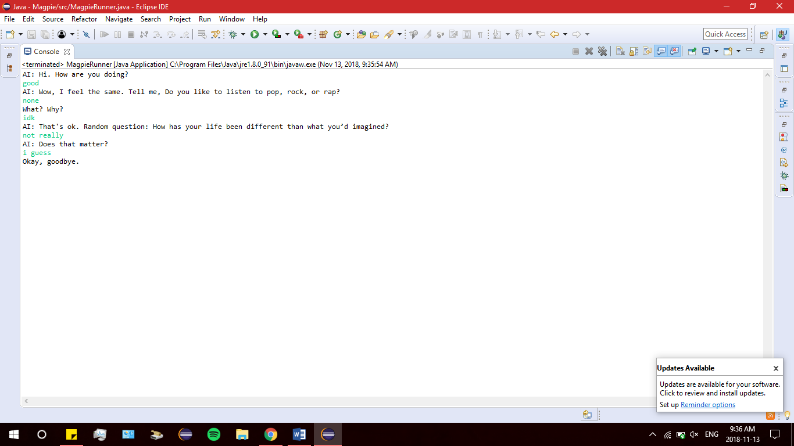
* Screenshots:
  + 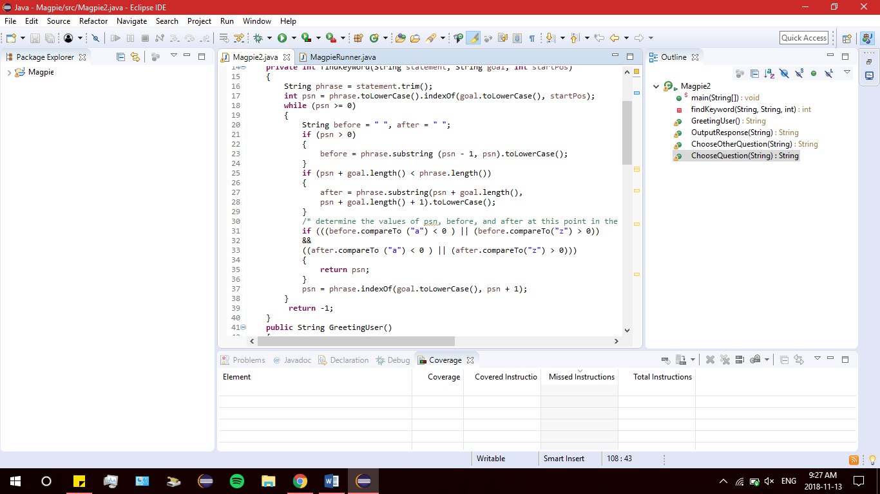 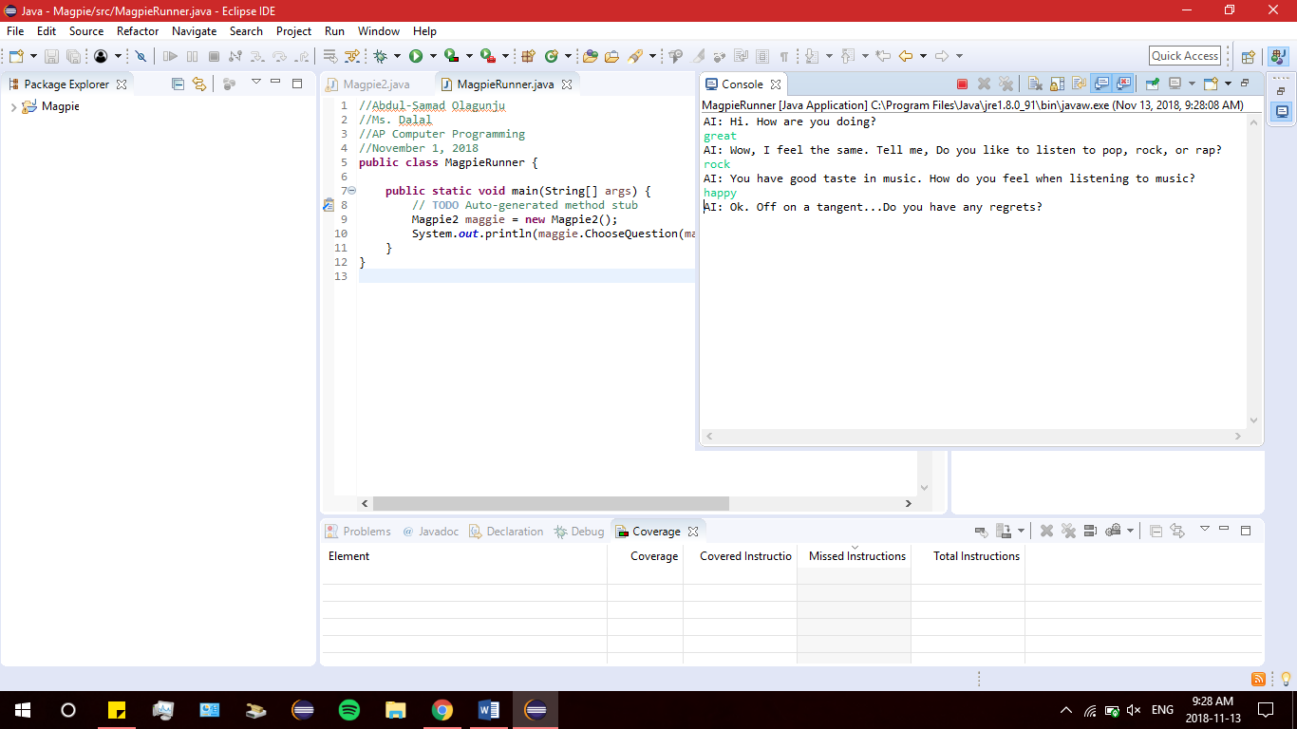

**Requirements:**

Problem: Users need an interactive agent that can communicate with them 24/7 and provide meaningful conversations.

Plan:

* Purpose: To design a chat box that can interact with an individual and provide them with a conversation.
* Deliverables:
  + Software for chat box
* Potential Customers:
  + Lonely People
  + People looking for support

Defining Resources:

* AP Computer Science Magpie Document
* Java API

Flow-chart :

